PROFESSIONAL BUSINESS COMMUNICATION

**PROJECT REPORT – GIG ECONOMY**

**Introduction**

The gig economy, also known as the "freelance economy" or "on-demand economy," represents a transformative shift in the way people work and earn a living. In the traditional job market, individuals typically pursue long-term, full-time employment with a single employer. However, the gig economy presents an alternative model where work is characterized by short-term contracts, freelance projects, and temporary, flexible jobs. This new paradigm is driven by technology and changing workforce preferences, offering both opportunities and challenges to workers, businesses, and the economy as a whole.

At the heart of the gig economy are digital platforms and mobile apps that connect workers (often referred to as "gig workers" or "independent contractors") with employers or customers seeking specific services or tasks. These platforms cover a wide range of industries, from transportation and delivery services to creative and professional services, making it a diverse and dynamic ecosystem.

Key features of the gig economy include flexibility, independence, and the ability to choose when and where to work. Gig workers often have the freedom to select the gigs that align with their skills, availability, and financial goals. While this flexibility can be appealing, it also comes with potential drawbacks, such as income volatility and limited access to traditional employment benefits like health insurance and retirement plans.

The gig economy has reshaped the way individuals approach work, offering opportunities for part-time employment, supplemental income, and career diversification. It has also led to debates about labor rights, job security, and the classification of gig workers as employees or independent contractors. Policymakers and businesses are grappling with the need to strike a balance between innovation and worker protection within this evolving labor market.

As the gig economy continues to grow and adapt, it presents a complex landscape with significant economic, social, and regulatory implications. Understanding its nuances is crucial for anyone interested in the future of work and the broader shifts in how people make a living in the modern world.

**History of Gig Economy**

The gig economy, characterized by short-term, flexible work arrangements, has become a prominent and transformative force in the modern labor market. To understand its present-day significance, it's essential to delve into its historical roots. This report offers a comprehensive overview of the history of the gig economy, tracing its evolution from ancient times to the present day.

Ancient Roots of Gig Work

The concept of gig work, characterized by individuals performing temporary tasks or services for compensation, has ancient roots that date back to early civilizations. While the term "gig economy" is a relatively recent development, the principles of short-term, task-based work can be traced to various ancient societies. Here are some examples of ancient roots of gig work:

Ancient Rome:

In ancient Rome, there were examples of laborers who engaged in gig work. These workers often took on specific construction projects, agricultural tasks, or other temporary jobs in exchange for a fixed fee or payment.

The Roman practice of hiring temporary workers for specific tasks is reminiscent of the modern gig economy's project-based nature, where individuals take on short-term assignments or contracts.

Medieval Guilds:

During the Middle Ages, guilds and craft associations were prevalent. Craftsmen and artisans, including blacksmiths, weavers, and carpenters, often operated as independent contractors.

Guild members would work on commissioned projects, creating goods or providing services on a per-project basis. This decentralized and project-oriented work model shares similarities with gig work in the sense that individuals performed specialized tasks as needed.

Ancient China:

Ancient China also had a system of labor where workers engaged in temporary or seasonal tasks. For example, during periods of harvest, agricultural workers were hired for their expertise in harvesting crops, much like gig workers today who offer specific skills or services for short durations.

This seasonal hiring practice reflects the episodic and project-based nature of gig work.

Ancient Egypt:

In ancient Egypt, various types of laborers, including builders, artisans, and agricultural workers, were employed on a project-by-project basis. For instance, the construction of monumental structures such as the pyramids required the expertise of temporary laborers who worked on specific phases of the project.

The use of temporary workers for specific tasks mirrors the gig economy's reliance on specialized skills for short-term projects.

While the terminology and organizational structures of gig work were different in these ancient societies, the fundamental concept of individuals performing temporary or project-based tasks in exchange for compensation bears striking similarities to the modern gig economy. These historical examples illustrate that gig work has been a part of human labor practices for millennia, adapting to the needs and circumstances of different eras and cultures.

Industrial Revolution and Piecework

The Industrial Revolution, spanning the late 18th and 19th centuries, brought substantial changes to work patterns. The introduction of factories and mass production gave rise to piecework, where laborers were paid based on the number of pieces or units they produced. This system laid the foundation for task-based payment that characterizes the modern gig economy. Simultaneously, cottage industries flourished, with artisans working independently from their homes on specialized tasks, foreshadowing gig workers' non-traditional workplaces.

Post-World War II Era and the Rise of Freelancing

The post-World War II era witnessed significant changes in the world of work, including the rise of freelancing as a prominent gig work category. This period, which encompasses the mid-20th century, saw a shift in employment patterns and the emergence of freelancers in various industries. Here's an exploration of the post-World War II era and the rise of freelancing:

Economic and Social Context

1. Post-War Boom:

After World War II, many countries experienced a period of economic growth and recovery. This era of prosperity created opportunities for individuals to explore alternative work arrangements.

2. Technological Advancements:

Advances in technology, particularly in communication and transportation, made it easier for individuals to work independently and connect with clients.

Factors Contributing to the Rise of Freelancing

1. Media and Creative Industries:

In the post-war era, the media and creative industries experienced significant growth. Writers, artists, and journalists increasingly found opportunities to work independently, submitting articles, artwork, or manuscripts on a freelance basis to various publications.

2. Expansion of the Services Sector:

The services sector expanded during this period, creating opportunities for professionals such as consultants, marketing experts, and trainers to offer their expertise on a freelance basis.

3. Temporary Work Agencies:

The emergence of temporary work agencies, also known as temp agencies, played a crucial role in the rise of freelancing. These agencies connected workers with short-term job opportunities across various industries.

Digital Revolution and the Birth of the Modern Gig Economy

The late 20th century brought about the digital revolution, ushering in a new era for the gig economy. The advent of the internet and digital technologies enabled online platforms to connect freelancers with clients. Platforms like Upwork (formerly Elance and oDesk) and TaskRabbit allowed individuals to offer their skills and services to a global audience, democratizing gig work. This digital transformation also gave rise to platform-based gig work, where workers find jobs through online platforms, expanding the gig economy's reach and diversity.

Key Milestones in the 21st Century

The 21st century has seen remarkable developments in the gig economy, with key milestones that have transformed the nature of work and how people engage in gig-related activities. Here are some of the most significant milestones in the gig economy during this century:

Rise of Ridesharing (2000s):

The 21st century began with the emergence of ridesharing platforms like Uber and Lyft, which revolutionized the transportation industry. These platforms allowed individuals to become independent drivers, offering rides to passengers on a flexible schedule.

The concept of ridesharing reshaped urban transportation, providing an alternative to traditional taxis and public transportation.

Sharing Economy (2010s):

The sharing economy gained momentum in the early 2010s with platforms like Airbnb. These platforms enabled homeowners and renters to list their properties for short-term stays, creating additional income streams.

The sharing economy expanded beyond accommodations to include services like peer-to-peer car rentals (e.g., Turo) and equipment sharing (e.g., Toolshed), further diversifying the gig economy.

Gig Work in the Gigantic Platform Era (2010s - Present):

The gig economy continued to evolve, with the emergence of a wide range of platforms and apps that facilitated gig work. These platforms spanned various sectors, including food delivery (e.g., DoorDash, Grubhub), grocery shopping (e.g., Instacart), and personal assistance (e.g., TaskRabbit).

The convenience and accessibility of these platforms led to the rapid growth of gig work across multiple industries, making it a mainstream employment option.

Freelancing Platforms (Upwork, Freelancer, Fiverr, etc.):

Freelancing platforms like Upwork (formerly Elance and oDesk), Freelancer, and Fiverr experienced significant growth in the 21st century. These platforms allowed freelancers to connect with clients globally, offering a wide range of services.

Freelancers on these platforms could find work in fields such as writing, graphic design, web development, and digital marketing, contributing to the diversification of the gig economy.

Gig Work During the COVID-19 Pandemic (2020):

The COVID-19 pandemic had a profound impact on the gig economy. While some gig workers experienced increased demand in sectors like food delivery and grocery shopping due to lockdowns, others faced job loss and reduced opportunities.

The pandemic underscored the vulnerabilities of gig workers, highlighting the need for improved labor protections and benefits.

Regulatory Responses (Ongoing):

Governments and regulatory bodies in various countries have been grappling with how to regulate gig work effectively. This has led to ongoing debates and policy changes.

Some regions have implemented laws to extend certain benefits, such as healthcare and minimum wage guarantees, to gig workers. However, the classification of gig workers as employees or independent contractors remains a contentious issue.

Worker Activism and Organizing (Ongoing):

Gig workers and labor activists have become increasingly vocal about their rights and working conditions. This has led to the formation of gig worker unions and organizations advocating for better pay, benefits, and job security.

High-profile legal battles and strikes by gig workers have drawn attention to the need for fair treatment and protection within the gig economy.

These milestones represent key developments in the 21st-century gig economy, reshaping how people work and engage in the labor market. The gig economy has become a diverse and influential sector that continues to evolve in response to technological advancements, economic shifts, and changing labor dynamics.

Covid-19 impact on gig economy

The COVID-19 pandemic had a profound and multifaceted impact on the gig economy, affecting both gig workers and the platforms they operate on. Here are some key ways in which the pandemic influenced the gig economy:

Shifts in Demand:

Surges in Demand: Some sectors of the gig economy experienced increased demand during the pandemic. For example, food delivery services (e.g., UberEats, DoorDash) and grocery delivery platforms (e.g., Instacart) saw a surge in orders as people avoided in-person shopping and dining.

Reduced Demand: Conversely, gig workers in sectors like ridesharing and the sharing economy (e.g., Airbnb) faced a significant drop in demand as travel restrictions and lockdowns took effect. With fewer people traveling and staying in shared accommodations, many gig workers lost income.

Safety Concerns:

Gig workers faced heightened safety concerns due to the nature of their work, which often involved close contact with others. Rideshare drivers, for instance, were exposed to the risk of virus transmission from passengers. Many gig workers adopted safety measures like mask-wearing and sanitizing their vehicles.

Job Loss and Economic Uncertainty:

Some individuals turned to gig work as a source of income after losing their traditional jobs due to pandemic-related layoffs. Gig work provided a way to make ends meet during a period of economic uncertainty.

However, the pandemic also exposed the lack of job security and benefits in the gig economy. Many gig workers found themselves without access to healthcare, sick leave, or unemployment benefits when they needed them most.

Labor Activism and Advocacy:

The pandemic spurred increased activism among gig workers, who demanded better protections and benefits. Protests, strikes, and legal actions against gig platforms drew attention to the precarious working conditions and lack of safety nets for gig workers.

Some gig worker organizations called for hazard pay, access to personal protective equipment, and expanded worker rights during the pandemic.

Platform Responses:

Many gig platforms responded to the pandemic by implementing safety measures, such as contactless deliveries and in-app health checks. Some also provided financial assistance to gig workers who contracted the virus or were quarantined.

Some platforms expanded their services to include essential goods delivery to adapt to changing consumer needs during lockdowns.

Policy Changes and Regulation:

Governments and regulators grappled with how to address the unique challenges posed by the gig economy during the pandemic. Some regions implemented temporary measures, such as unemployment benefits for gig workers, while others explored long-term regulatory changes.

The classification of gig workers as employees or independent contractors became a subject of debate, with potential implications for their access to benefits and protections.

Accelerated Digitization:

The pandemic accelerated the adoption of digital platforms for work, as more individuals and businesses turned to online marketplaces for various services.

This digital transformation may have long-term effects on the gig economy, shaping the way people find and engage in gig work even after the pandemic subsides.

In summary, the COVID-19 pandemic brought both challenges and opportunities to the gig economy. It highlighted the vulnerability of gig workers and the need for improved protections while also showcasing the adaptability of the gig economy in responding to changing consumer demands. The long-term consequences of the pandemic on the gig economy will continue to be a subject of study and debate as the world adjusts to a post-pandemic reality.

**Characteristics of Gig Economy**

The gig economy, short for "gigantic economy," is a labor market characterized by the prevalence of short-term contracts or freelance work as opposed to permanent jobs. In the gig economy, individuals often work on a project-to-project or task-to-task basis, taking on temporary or flexible jobs, commonly referred to as "gigs." These gigs can range from driving for rideshare companies like Uber and Lyft to providing services on platforms like TaskRabbit, freelancing on websites like Upwork, or even participating in the sharing economy through platforms like Airbnb.

Key characteristics of the gig economy include:

On-Demand Services: Many gig economy platforms offer on-demand services, allowing customers to request and receive services almost instantly. For example, food delivery services like DoorDash and grocery delivery services like Instacart provide quick access to goods and services.

Variety of Work Arrangements: Gig work can take on various forms, including one-time projects, short-term contracts, and ongoing freelance work. This diversity of work arrangements allows individuals to choose the type of gig that suits their preferences and skills.

Low Entry Barriers: In many cases, entering the gig economy requires minimal upfront investment. Workers can often get started with basic equipment, such as a smartphone or a computer, making it accessible to a wide range of people.

Geographic Independence: Gig work is not restricted to a specific location. Freelancers and gig workers can often work from anywhere with an internet connection, reducing the importance of physical proximity to job opportunities.

Crowdsourcing: Some gig platforms use crowdsourcing models, where a large number of individuals contribute to a project, often in small, discrete tasks. This approach is common in industries like data annotation, content moderation, and open-source software development.

Emerging Gig Niches: As the gig economy continues to evolve, new niches and opportunities emerge. For example, there is a growing market for virtual assistants, online tutoring, and e-commerce order fulfillment services within the gig economy.

Shift Away from Traditional Employment: The gig economy has led to a shift away from traditional 9-to-5 employment for some individuals who prefer the autonomy and flexibility it offers. This shift has implications for the broader workforce and the way work is structured.

Skill Matching Algorithms: Some gig platforms use algorithms to match workers with jobs based on their skills, experience, and availability. This can streamline the job-search process for both workers and employers.

Social Impact: The gig economy has had social and economic impacts, such as enabling income opportunities for individuals who may have difficulty accessing traditional employment, like retirees, students, and individuals with disabilities.

Regulatory Adaptation: Governments and regulatory bodies have been adapting to the gig economy by introducing new regulations and labor laws to address issues like worker classification, minimum wage, and benefits. These adaptations vary by region and continue to evolve.

Education and Training: As gig work becomes more prevalent, there is a growing interest in providing education and training to help gig workers succeed in their roles and navigate the challenges of freelancing, including financial planning and tax considerations.

Flexibility: Gig workers have the flexibility to choose when and where they work, allowing them to balance work with other commitments and lifestyles.

Independent Contractor Status: Many gig workers are considered independent contractors or freelancers, which means they are not entitled to the same benefits and protections as traditional employees, such as health insurance, paid time off, and workers' compensation.

Digital Platforms: The gig economy heavily relies on digital platforms and mobile apps that connect workers with employers or customers. These platforms often facilitate payment and rating systems.

Diverse Job Types: Gigs in the gig economy can encompass a wide range of job types, from driving and delivery services to writing, design, and consulting.

Income Variability: Gig workers may experience income variability, as their earnings can depend on factors like demand for their services, the number of gigs they take on, and their own performance.

Diverse Skill Sets: The gig economy accommodates a wide range of skills and talents. Whether you're a graphic designer, software developer, writer, handyman, or driver, there are gig opportunities available in various industries and sectors.

Global Reach: Many gig platforms have a global reach, allowing individuals to work with clients or customers from around the world. This can lead to increased opportunities and exposure for gig workers.

Rating and Review Systems: Reputation is crucial in the gig economy. Many platforms include rating and review systems that allow both workers and customers to provide feedback and build trust within the community.

No Fixed Hours: Gig workers typically have the freedom to set their own hours, which can be advantageous for those seeking part-time or side jobs or those who want to balance work with other commitments, such as education or family responsibilities.

Multiple Gigs: Many gig workers take on multiple gigs simultaneously, diversifying their income sources. This can provide financial stability and reduce dependence on a single employer.

Resource Sharing: Some gig economy models involve resource sharing, where individuals can rent out their assets, such as their homes or cars, to others. This is often referred to as the sharing economy and is exemplified by platforms like Airbnb and Turo.

Digital Payments: Payment in the gig economy is typically done digitally through the platform, making transactions quick and convenient. Workers can often choose how they receive payments, such as direct deposit or through digital payment services like PayPal.

Skill Development: Gig work can provide opportunities for skill development and entrepreneurship. Freelancers and gig workers often need to manage their own businesses, which includes marketing their services, setting prices, and handling administrative tasks.

Income Volatility: While gig work offers flexibility, it can also come with income volatility. Gig workers may experience fluctuations in earnings from month to month, depending on the demand for their services and their ability to secure gigs.

Legal and Regulatory Challenges: The gig economy has raised legal and regulatory challenges in many jurisdictions. Questions about the employment status of gig workers, their access to benefits, and labor rights are subjects of ongoing debate and litigation.

Job Mobility: Gig work can provide workers with the ability to switch between gigs and explore different opportunities easily, which can be beneficial for career exploration or pursuing multiple interests.

Overall, the gig economy is a dynamic and evolving labor market that offers both opportunities and challenges for workers and businesses alike. Its continued growth and impact on the traditional workforce are areas of ongoing interest and study.

The gig economy has grown significantly in recent years, driven by technological advancements and changing workforce preferences. While it offers opportunities for flexible work arrangements and supplemental income, it has also raised concerns about job security, benefits, and labor rights for workers, leading to ongoing debates about how to regulate and support this evolving labor market.

**Skills and Education**

The gig economy, characterized by short-term and freelance work arrangements, has transformed the way people earn a living in recent years. It offers flexibility and independence, but it also raises questions about the skills and education needed to thrive in this rapidly evolving job market. In this discussion, we'll explore the skills and educational considerations for individuals looking to succeed in the gig economy.

**Skills for the Gig Economy**

1. **Adaptability**: Gig workers often switch between various projects and clients. The ability to adapt to different industries, tasks, and work environments is crucial. Gig workers must continually learn and adjust to remain relevant and valuable across multiple gigs.
2. **Digital Literacy**: In an increasingly digital world, basic digital literacy is essential. Proficiency with common software, online communication tools, and digital marketing platforms can be the difference between securing gigs and being overlooked.
3. **Communication Skills**: Effective communication is vital in the gig economy. Freelancers need to clearly convey their ideas, negotiate terms, and maintain good relationships with clients. Strong written and verbal communication skills can lead to repeat business and referrals.
4. **Self-Motivation**: Gig workers must be self-starters. They often work independently and set their own schedules, so self-motivation is crucial for meeting deadlines and achieving desired outcomes.
5. **Financial Literacy**: Managing finances in the gig economy can be complex. Gig workers should understand how to budget, save for taxes, and plan for retirement, as they often lack the traditional benefits provided by full-time employment.

**Education in the Gig Economy**

1. **Lifelong Learning**: The gig economy thrives on innovation and change. Continuous learning is vital to stay competitive. Freelancers should invest in courses, workshops, and online learning platforms to acquire new skills and knowledge.
2. **Skill-Specific Education**: Depending on the gig, acquiring specific skills or certifications may be necessary. For example, graphic designers may need proficiency in Adobe Creative Suite, while web developers may require knowledge of coding languages like HTML and CSS.
3. **Entrepreneurship Education**: Many gig workers function as small business owners. Courses in entrepreneurship can help individuals understand business operations, marketing, and financial management.
4. **Networking and Mentoring**: Education is not limited to formal classes. Networking and mentorship can be invaluable for gig workers. Joining industry-specific groups, attending conferences, and seeking guidance from experienced professionals can open doors to new opportunities.
5. **Legal and Contractual Education**: Understanding contracts, intellectual property rights, and legal obligations is essential. Freelancers should consider legal education or consulting to protect their interests in the gig economy.

**Challenges and Future Outlook**

While the gig economy offers flexibility and opportunities, it also presents challenges. Income stability, access to benefits, and job security are concerns for gig workers. Additionally, as automation and AI advance, some traditional gig roles may be replaced.

To thrive in the gig economy, individuals must remain agile, adaptable, and committed to learning throughout their careers. Education and skills development are key elements of this journey, enabling gig workers to navigate the ever-changing landscape and build sustainable careers in a rapidly evolving job market.

**Policy Implications and Conclusion**

**Policy Implications**

1. **Social Safety Nets**: Policymakers must address the lack of traditional benefits for gig workers. Implementing portable benefits and safety nets that are not tied to specific employers can provide financial security in the gig economy.
2. **Education Accessibility**: Increasing access to affordable education and upskilling opportunities is essential. Government programs, scholarships, and partnerships with educational institutions can help gig workers acquire the skills they need.
3. **Labor Protections**: Labor laws and regulations need to adapt to the gig economy. Ensuring fair compensation, protection against exploitation, and addressing issues like misclassification are important policy considerations.
4. **Taxation and Financial Planning**: Tax policies should be adjusted to accommodate gig workers. Simplified tax reporting and guidance on financial planning can help freelancers manage their finances effectively.

**Conclusion**

The gig economy is here to stay, offering both opportunities and challenges for individuals seeking flexible work arrangements. Success in this dynamic job market requires a combination of skills and education. Adaptability, digital literacy, communication, self-motivation, and financial literacy are essential skills for gig workers.

Education in the gig economy is a lifelong pursuit, encompassing both formal and informal learning. Lifelong learning, skill-specific education, entrepreneurship training, networking, and legal knowledge are all critical components of a gig worker's education journey.

Policymakers also play a crucial role in supporting gig workers through social safety nets, improved access to education, labor protections, and tax policies that reflect the unique needs of freelancers.

In conclusion, the gig economy offers opportunities for those who are prepared to embrace its challenges. By acquiring the right skills, continually educating themselves, and advocating for supportive policies, individuals can thrive in this evolving employment landscape.

**Empowering Youth through the Gig Economy**

**Executive Summary**

The gig economy, characterized by short-term contracts, freelance work, and temporary positions, has rapidly expanded in recent years, offering various opportunities for employment and income generation. This report aims to explore how the youth can benefit from the gig economy, highlighting its potential advantages, challenges, and policy implications. The gig economy can empower young individuals by providing them with flexible work options, skill development opportunities, and a pathway to economic independence. However, it also presents challenges such as job insecurity and the need for adequate labor protections.

**Introduction**

The gig economy, also known as the freelance or on-demand economy, represents a significant shift in the way work is organized and performed. It offers a diverse range of employment opportunities, often facilitated through digital platforms and apps, making it particularly appealing to the younger generation. This report delves into the various ways in which the youth can benefit from the gig economy, examining both the positive and negative aspects of this evolving job market.

**Benefits of the Gig Economy for Youth**

1. Flexibility

One of the primary advantages of the gig economy is the flexibility it offers to young workers. Traditional nine-to-five jobs often limit personal time and hinder work-life balance. In contrast, the gig economy allows individuals to choose when and where they work, enabling them to better align their work commitments with personal pursuits, such as education, family, or travel. This flexibility can be especially appealing to young adults who seek a dynamic lifestyle.

2. Skill Development

The gig economy provides numerous opportunities for skill development. As individuals take on various freelance projects or gigs, they acquire a diverse set of skills, from graphic design and coding to marketing and customer service. This continuous learning process can be invaluable for young people who are eager to build their skill set and enhance their employability in an ever-changing job market.

3. Entrepreneurship

Engaging in the gig economy can ignite entrepreneurial spirit among young individuals. Many gig workers have the chance to start their own small businesses or freelance enterprises. This can serve as a stepping stone for those who aspire to become entrepreneurs, offering them the opportunity to test business ideas, build a client base, and generate income.

4. Economic Independence

For young people who face financial constraints or lack a traditional job history, the gig economy can provide a means of achieving economic independence. Gig work allows them to earn income without the need for formal qualifications or extensive experience, enabling them to cover basic living expenses and achieve financial autonomy.

5. Diversity of Opportunities

The gig economy encompasses a wide range of sectors, from ride-sharing and food delivery to content creation and consulting. This diversity of opportunities caters to a variety of interests and skill sets, ensuring that young people can find gigs that align with their passions and abilities.

Challenges and Concerns

While the gig economy offers numerous benefits, it also presents several challenges and concerns for young workers:

1. Job Insecurity

Gig workers often lack job security and stability. They may face fluctuations in income and encounter periods of unemployment between gigs. This can be stressful and financially precarious, especially for those with dependents or high living expenses.

2. Lack of Benefits

Traditional employees typically enjoy benefits such as health insurance, retirement plans, and paid time off. In contrast, gig workers are often considered independent contractors and may not have access to these essential benefits. This absence of benefits can hinder young workers' financial security and well-being.

3. Labor Protections

The gig economy raises questions about labor protections. Many gig workers lack the legal protections and rights afforded to traditional employees, such as minimum wage guarantees and workplace safety regulations. Ensuring that gig workers are adequately protected is a pressing concern for policymakers.

4. Income Inequality

The gig economy can exacerbate income inequality. High-demand, high-skill gigs may offer substantial income, while low-skill, low-demand gigs may provide minimal compensation. This disparity can disproportionately affect young workers who may struggle to access high-paying opportunities.

Policy Implications

To maximize the benefits and mitigate the challenges associated with the gig economy for young workers, policymakers should consider several key strategies:

1. Labor Protections

Efforts should be made to extend labor protections to gig workers, ensuring they have access to fair wages, workplace safety, and other essential benefits. Policymakers should explore models that balance gig workers' flexibility with their need for security.

2. Skill Development

Investing in programs that provide gig workers with access to affordable education and skill development opportunities can enhance their long-term employability and career prospects.

3. Financial Literacy

Promoting financial literacy among young gig workers can help them manage their income, savings, and retirement planning effectively. Educational initiatives and resources should be readily available.

4. Access to Benefits

Exploring innovative solutions to provide gig workers with access to benefits, such as portable benefits models or government-sponsored programs, can alleviate some of the financial stress associated with gig work.

**Conclusion**

The gig economy offers significant potential benefits to young individuals, including flexibility, skill development, entrepreneurial opportunities, and economic independence. However, it also poses challenges related to job insecurity, the lack of benefits, labor protections, and income inequality. Policymakers, employers, and gig workers themselves must collaborate to harness the advantages of the gig economy while addressing its shortcomings. With the right policies and support systems in place, the gig economy can be a powerful tool for empowering youth in their pursuit of economic success and personal fulfillment.

**Key players and its background**

Key players and its background:

1. Uber

Uber, founded in 2009 by Travis Kalanick and Garrett Camp, is arguably one of the most iconic companies in the gig economy. It disrupted the traditional taxi industry by creating a platform that connects riders with drivers through a mobile app. Uber operates in hundreds of cities globally, offering a range of services, including UberX (standard rides), UberEats (food delivery), and even Uber Freight (for shipping and logistics). The platform allows individuals to work as independent contractors, providing them with the flexibility to set their own schedules.

Uber has faced regulatory challenges, legal disputes, and controversies related to driver classification, safety concerns, and labor rights. These issues have highlighted some of the ongoing debates surrounding the gig economy.

2. Airbnb

Founded in 2008 by Brian Chesky, Joe Gebbia, and Nathan Blecharczyk, Airbnb has transformed the hospitality and lodging industry. The platform enables individuals to rent out their homes, apartments, or spare rooms to travelers, providing an alternative to traditional hotels. Hosts on Airbnb have the flexibility to decide when and how they want to rent their spaces, making it a quintessential gig economy platform.

Airbnb's success has made it a household name, but it has also faced challenges related to safety, zoning regulations, and concerns about its impact on housing markets in certain cities. Nevertheless, it remains a dominant player in the short-term rental industry.

3. Upwork and Fiverr

Upwork and Fiverr are two prominent online freelancing platforms that connect businesses with skilled freelancers. These platforms cater to a wide range of industries and professions, including graphic design, writing, web development, and digital marketing. Freelancers can create profiles, bid on projects, and negotiate terms with clients, allowing them to work on a project basis and choose their clients.

Upwork and Fiverr have become integral to the gig economy, empowering freelancers to build their businesses and offering businesses a cost-effective way to access specialized talent. They also provide tools for tracking work, facilitating payments, and managing projects, making it easier for freelancers to thrive in the gig economy.

4. TaskRabbit

TaskRabbit, founded in 2008 by Leah Busque, is a platform that connects individuals who need help with various tasks, errands, and odd jobs with skilled "Taskers" who can complete these tasks. TaskRabbit has found success by offering convenience and flexibility to users, allowing them to outsource tasks ranging from furniture assembly to grocery shopping to house cleaning.

The platform has expanded to offer virtual tasks and online services, reflecting the evolving needs of its users. TaskRabbit's gig workers have the autonomy to choose the tasks they want to complete and set their rates, making it an attractive option for those seeking short-term or flexible work opportunities.

These key players, along with many others in the gig economy, have reshaped industries, economies, and the way people work. Their impact has sparked discussions about labor rights, regulation, and the future of work in an increasingly digitized and interconnected world.

5. Lyft

Lyft, founded in 2012 by Logan Green and John Zimmer, is a direct competitor to Uber in the ride-sharing industry. Like Uber, Lyft allows drivers to use their own vehicles to provide rides to passengers through a mobile app. Lyft has grown to operate in hundreds of cities in the United States and Canada, offering a similar gig work model as Uber, where drivers can set their own schedules.

Lyft has focused on creating a more passenger-friendly and community-oriented image compared to some of its competitors. It has also ventured into other forms of transportation, including bike and scooter rentals. Lyft's presence in the gig economy has contributed to the expansion of ride-sharing services as a viable income source for many individuals.

6. DoorDash

DoorDash, founded in 2013 by Tony Xu, Evan Moore, Andy Fang, and Stanley Tang, is a food delivery platform that connects users with local restaurants and drivers, known as "Dashers." It has experienced rapid growth, especially during the COVID-19 pandemic, as more people turned to food delivery services. Dashers work on a flexible basis, delivering food orders to customers' doorsteps.

DoorDash has faced scrutiny over issues related to worker classification, including debates about whether Dashers should be considered employees or independent contractors. These discussions have brought attention to labor rights and the treatment of gig workers in the food delivery industry.

7. Instacart

Instacart, founded in 2012 by Apoorva Mehta, Max Mullen, and Brandon Leonardo, offers grocery delivery and pick-up services. Instacart connects customers with personal shoppers who collect and deliver groceries from local stores. This model allows individuals to earn income by shopping for others, and it has seen significant growth in recent years, particularly as more consumers opt for online grocery shopping.

Instacart shoppers, similar to other gig workers, have the flexibility to choose their working hours and determine their own schedules. However, issues related to pay and working conditions have also surfaced in the gig grocery shopping industry, prompting discussions about labor rights and regulations.

9. Grubhub

Grubhub, founded in 2004 by Matt Maloney and Mike Evans, is a food delivery and takeout platform. It connects users with local restaurants and delivery drivers, offering a wide range of cuisine options. Gig workers, often referred to as delivery partners, use their own vehicles to fulfill orders placed through the Grubhub app. The platform has become increasingly popular as more consumers seek the convenience of having restaurant meals delivered to their homes or workplaces.

Grubhub has faced competition from other food delivery platforms like DoorDash and UberEats and has been at the center of discussions about driver earnings and worker classification.

10. Postmates

Postmates, founded in 2011 by Bastian Lehmann, Sean Plaice, and Sam Street, is another food delivery platform. It operates in various U.S. cities and offers customers the ability to order from local restaurants, grocery stores, and convenience stores. Postmates couriers, or "Postmates," use their own vehicles to fulfill deliveries and can choose when and where they work.

The company gained attention for its versatile delivery options, which include not only restaurant meals but also various retail items. Postmates was acquired by Uber in 2020, marking a significant consolidation in the gig economy and ride-sharing industries.

11. TaskRabbit (Expanding Services)

While TaskRabbit was previously mentioned, it's worth noting that it has expanded its range of services beyond household tasks. TaskRabbit now offers virtual services, including tutoring, remote administrative work, and more. This expansion reflects the gig economy's adaptability to changing market demands and the increasing digitization of work.

12. Amazon Flex

Amazon Flex, launched by Amazon in 2015, is a delivery service that allows individuals to deliver Amazon packages using their own vehicles. Flex drivers, or "Amazon Flexers," work on a gig basis, selecting delivery blocks that fit their schedules. Amazon Flex is part of Amazon's broader logistics strategy to enhance its delivery capabilities, particularly for Prime members.

Amazon Flex, like other gig platforms, has sparked discussions about worker classification and pay rates. It also highlights how tech giants like Amazon have entered the gig economy to meet growing demand for fast and efficient package delivery.

These key players offer a glimpse into the diverse opportunities within the gig economy, ranging from food delivery and grocery shopping to package delivery and a wide array of task-based services. Their presence in various sectors continues to impact how people work and how services are delivered in today's rapidly evolving job market.

**Challenges and Controversy**

The gig economy, also known as the on-demand economy, is a rapidly growing trend . It refers to a labor market where temporary, short-term, or freelance jobs are the norm instead of the traditional nine-to-five office jobs. This report explores the challenges and controversies faced by gig workers , shedding light on the issues that accompany this evolving employment landscape.

**Challenges Faced by Gig Workers**

**Job Insecurity**

Gig workers often find themselves in a state of perpetual job insecurity. Unlike traditional employment, gig workers are typically engaged on a project or assignment basis, which translates into financial instability and makes it difficult for them to plan for the future. This uncertainty can have profound consequences for their well-being.

**Income Instability**

Another significant challenge facing gig workers is income instability. Due to the irregular and unpredictable nature of gig work, they often experience fluctuations in income. This inconsistency can make it challenging for them to meet their financial obligations and plan for a stable future. The gig economy's promise of flexibility sometimes comes at the cost of financial stability.

**Lack of Formalization**

Many gig workers operate within the informal sector. This lack of formalization limits their access to credit, government support programs, and other vital resources. The absence of a structured work environment can hinder their ability to secure loans or benefit from government initiatives, perpetuating financial vulnerability.

**Lack of Legal Protection & Social Security**

One of the gravest issues faced by gig workers is the lack of legal protection and social security. These workers are often excluded from India's labor laws, leaving them without recourse in cases of workplace harassment, discrimination, or unfair termination. Additionally, they do not enjoy access to social security benefits such as health insurance, retirement plans, and paid leave. This leaves them vulnerable to unexpected hardships.

**Unequal Bargaining Power**

Gig workers often lack the bargaining power to negotiate fair compensation and working conditions. In a digital landscape teeming with workers, competition is fierce, and gig workers may be compelled to accept less favorable terms. This inherent imbalance can lead to exploitation and hinder their ability to earn a decent living.

**Payment Issues**

Delayed or non-payment of wages is a pervasive issue for gig workers. The absence of mechanisms to ensure timely payments exacerbates their financial instability. Addressing this problem requires the establishment of mechanisms that enable gig workers to receive their dues promptly and resolve payment disputes efficiently.

**Training and Upskilling**

Many gig workers lack the necessary skills to perform their work effectively. Opportunities for upskilling and career advancement are often limited, leaving them ill-prepared to meet the demands of an ever-changing job market. Bridging this skills gap is essential for the long-term success and financial well-being of gig workers.

**Social Stigma**

Gig work is sometimes viewed as a temporary or low-paying option, leading to social stigma and a lack of recognition for the contributions of gig workers. This social bias can affect their self-esteem and hinder their ability to command fair compensation and working conditions.

**Road Ahead for the Gig Economy**

The gig economy is poised for substantial growth, with impressive figures indicating its potential. According to the International Labour Organization (ILO), India boasts the second-largest gig economy globally, with around 56% of all gig workers in the Asia-Pacific region. Projections from Nasscom estimate a Compound Annual Growth Rate (CAGR) of 17%, with 23.5 million gig workers and a market size of $455 billion by 2023. This growth aligns with India's ambition to become a $5 trillion economy by 2025.

The Boston Consulting Group (BCG) estimates that the Indian gig economy has the potential to create up to 90 million jobs in non-farm sectors, approximately 30% of India's workforce. Such growth is expected to yield efficiency and productivity gains, contributing up to 1.25% to India's GDP. Consequently, the gig economy holds the promise of providing employment opportunities and bolstering economic growth across various sectors and industries.

**Major Challenges in the Gig Economy**

**Less Social Protection and Perks**

Gig workers often lack the social protections and perks afforded to traditional employees. They must cover retirement and health insurance costs and use personal assets like cars and fuel. This model eliminates paid vacation and sick leave, leaving them financially responsible for these essential benefits.

**Service Conditions**

Low wages, deceptive incentives, opaque pay calculations, commission deductions, and constant monitoring on aggregator platforms have triggered massive protests by gig workers against aggregator terms of service. Such conditions have led to a pervasive sense of exploitation and discontent among gig workers.

**Entitlement Burden**

Gig workers are often expected to be fully qualified, with limited opportunities for skill development and career progression. This imbalance in the employment relationship places the burden of self-improvement squarely on the gig workers themselves, while traditional employers routinely invest in employee training and development.

**Outdated Regulatory Framework**

The gig economy remains largely unregulated, leaving workers with less job security and marginal returns. India's existing labor laws, designed for traditional employment models, are ill-equipped to address the unique challenges faced by gig workers. This regulatory gap has left many workers without the legal protections they deserve.

**Supply and Demand Mismatch**

There is already a surplus of potential online independent workers compared to available jobs, leading to wage stagnation and an increasingly competitive landscape. Gig workers are often caught in a race to the bottom, as oversupply drives down wages.

**The Gig Economy Brings Loneliness**

Independent gig workers, especially those who work remotely, can experience profound loneliness and isolation. The absence of regular social interactions found in traditional office environments can impact their mental well-being.

**Challenges from Conventional Players**

The gig economy poses significant challenges to established industries. Companies operating under gig principles, such as Airbnb and Uber, have disrupted traditional sectors like hospitality and transportation. In response, traditional players have lobbied government agencies to introduce regulations that protect their interests, potentially weakening the competitive advantage of gig-principle firms.

**Controversies of Gig Economy**

**1. Worker Classification:**

The controversy surrounding worker classification in the gig economy is rooted in whether gig workers should be considered independent contractors or employees. This determination has significant legal and financial consequences. Independent contractors typically do not receive the same level of benefits, job security, and legal protections as employees.

- Legal Implications: In many countries, including India, employment laws and regulations are designed to protect the rights of employees. If gig workers are classified as employees, they become entitled to various benefits and protections, such as minimum wage, overtime pay, and the right to unionize.

- Financial Implications: For employers, classifying workers as employees can be more expensive due to the added costs of benefits and compliance with labor laws. In contrast, treating workers as independent contractors can lead to cost savings.

**2. Wage Disparities:**

Gig workers often face wage disparities compared to their traditionally employed counterparts. The pay structures on many gig platforms can be complex and opaque, making it difficult for workers to understand how their compensation is determined.

- Protests and Demands: Wage disparities have led to protests and demands for fair compensation. Gig workers argue that their labor is undervalued, and they deserve to earn a living wage, particularly given the often unpredictable and precarious nature of gig work.

**3. Lack of Benefits:**

Gig workers frequently lack access to traditional employee benefits such as health insurance, retirement plans, and paid leave. This absence of benefits can leave them financially vulnerable, especially during times of illness or when planning for long-term financial security.

- Financial Vulnerability: Without benefits, gig workers must cover their own health insurance costs and may struggle to save for retirement. They also lack the safety net of paid leave, which can be particularly challenging during emergencies.

**4. Regulatory Challenges:**

The gig economy operates in a largely unregulated space, posing challenges for governments seeking to balance innovation with worker protection. Existing labor laws are often ill-suited to address the unique dynamics of gig work.

- Adaptation of Laws: Governments are faced with the complex task of adapting existing labor laws to protect gig workers while fostering innovation in the gig economy. Striking this balance requires careful consideration of the rights and responsibilities of both workers and platforms.

**5. Exploitation and Precarity:**

The flexible nature of gig work can lead to precarious employment situations, where workers have little job security and are vulnerable to exploitation. Gig workers may find themselves at the mercy of platform policies and may face exploitative conditions.

- Precarious Employment: Gig workers often lack the stability and predictability that traditional employment offers. They can be subject to sudden changes in demand, leading to income instability.

**6. Data Privacy:**

Gig platforms often collect extensive data about both workers and customers. This raises concerns about data privacy, including how this information is collected, stored, and used by companies.

- Privacy Concerns: Workers worry about the extent to which their personal data is collected and how it might be used. Privacy breaches or misuse of data can have serious implications for individuals.

**7. Market Dominance:**

Some gig economy platforms have achieved near-monopoly status in their respective sectors. This dominance can stifle competition and limit opportunities for gig workers. Platforms with significant market power may dictate terms to workers.

- Limited Choices: When a single platform dominates a market, gig workers may have limited options for finding work, reducing their bargaining power and ability to negotiate favorable terms.

**8. Impact on Traditional Industries:**

The gig economy has disrupted traditional industries like taxis, hotels, and food delivery. This disruption has led to tensions between traditional players and gig platforms, resulting in regulatory battles and market competition.

- Competitive Tensions: Traditional industries often view gig platforms as direct competitors. This has led to legal and regulatory battles as established players seek to protect their market share.

**Gig Workers and their characteristics**

**Introduction**

The gig economy has reshaped the contemporary labor landscape, with gig workers, also known as freelancers, independent contractors, or platform workers, playing a central role in this transformation. This comprehensive report explores the multifaceted nature of gig workers, delving deeply into their motivations, demographics, and skillsets to offer a thorough understanding of this dynamic workforce.

**Motivations of Gig Workers**

Gig workers are propelled by a myriad of motivations that distinguish them from their traditionally employed counterparts. These motivations are the driving force behind their choice to engage in gig work.

**1. Flexibility**

At the heart of gig work is flexibility, a defining feature that resonates with many gig workers. They cherish the autonomy to determine when, where, and how much they work. This flexibility allows them to create a work-life balance that suits their unique circumstances. For instance, parents may choose gig work to accommodate childcare responsibilities without compromising their career aspirations.

**2. Entrepreneurial Spirit**

A prominent trait among gig workers is their entrepreneurial spirit. They value the opportunity to be their own bosses, market their skills, and forge their career paths. This mindset aligns seamlessly with the gig economy's ethos of self-reliance and self-determination. Gig workers often view their engagements as small businesses, meticulously managing their operations and clients.

**3. Monetary Incentives**

Earnings potential serves as a powerful motivator for gig workers. Many enter the gig economy enticed by the prospect of higher income compared to traditional employment, particularly in sectors with high demand for specialized skills. The ability to set their rates and seek lucrative opportunities is an appealing aspect for gig workers.

**4. Skill Utilization and Job Satisfaction**

Gig work frequently enables individuals to harness and showcase their unique skills and expertise. This alignment between their abilities and work assignments leads to greater job satisfaction. Professionals in creative industries, IT, marketing, and consulting often turn to gig work as a means to express and capitalize on their talents.

**Demographics of Gig Workers**

Gig workers form a diverse tapestry, representing various age groups, genders, educational backgrounds, and geographic locations. The demographic diversity in this workforce is a testament to its inclusivity and accessibility.

**1. Age Diversity**

Initially perceived as predominantly young, the gig economy has expanded to encompass individuals of all ages. Older workers, often referred to as "silver gig workers," are increasingly participating in gig work. They engage for diverse reasons, such as supplementing retirement income, experiencing post-retirement transitions, or exploring new career avenues.

**2. Gender Inclusivity**

The gig economy has been instrumental in mitigating gender disparities in the workforce. It offers women greater opportunities for flexible work arrangements, enabling them to navigate family responsibilities while pursuing their careers. Women, therefore, constitute a significant and growing portion of gig workers, making substantial contributions to the gig economy.

**3. Educational Backgrounds**

Gig workers come from diverse educational backgrounds. While some hold advanced degrees and serve as freelance consultants or experts, others with limited formal education secure opportunities in sectors like ride-sharing, delivery services, and various gig economy platforms. This diversity highlights the versatility of gig work in accommodating individuals with varying skill levels.

**4. Geographic Diversity**

The reach of the gig economy extends far beyond urban centers. Gig workers are found in urban, suburban, and rural areas, albeit with variations in the types of available gigs and local demand. This geographic inclusivity enables gig work to serve as a source of income and employment in communities of various sizes and locations.

**Skillsets and Specializations**

The gig economy thrives on a diverse array of skillsets, addressing the multifaceted needs of employers and consumers across industries and sectors.

**1. Creative Professions**

Gig work frequently accommodates creative professionals such as writers, graphic designers, photographers, and artists. Their specialized skills are in high demand for projects ranging from content creation to marketing campaigns, website design, and artistic endeavors.

**2. Technical Expertise**

The technology sector is a burgeoning realm for gig workers, encompassing IT professionals, programmers, web developers, data analysts, and cybersecurity experts. Their skills are essential in addressing the evolving digital needs of businesses, ranging from software development to data management and cybersecurity.

**3. Service and Labor**

Service-oriented gig workers play pivotal roles in sectors such as transportation, delivery, hospitality, and household services. These roles require an array of skills, including customer service, time management, physical stamina, and adaptability to meet diverse customer needs.

**4. Professional Services**

Highly specialized professions like consulting, law, accounting, and healthcare are well-represented in the gig economy. These experts offer their services on a freelance basis, providing valuable insights, solutions, and expertise to businesses and individual clients.

**Challenges and Future Trends**

Despite its numerous opportunities, the gig economy presents its share of challenges. Gig workers often grapple with issues related to income stability, access to benefits, and employment rights. Evolving labor laws and regulatory frameworks continue to shape the gig economy's landscape, influencing the experiences of gig workers.

Looking ahead, the future of the gig economy holds several intriguing trends and developments. As technological advancements persist and society adapts to new working norms, gig work is expected to become even more ingrained in our daily lives. Policymakers, businesses, and individuals must collaborate to address the evolving needs of gig workers and ensure a fair, equitable, and sustainable future of work.

**Conclusion**

In conclusion, gig workers constitute a multifaceted and dynamic segment of the labor force. Their motivations, demographics, and skillsets significantly contribute to the vibrancy and adaptability of the gig economy. As the gig economy continues to expand and evolve, understanding and addressing the unique characteristics and challenges of gig workers remain imperative steps toward creating a more inclusive, equitable, and sustainable future of work.

**Types of Gig works and Platforms**

In the world of gig work, there are different ways people earn a living compared to the traditional nine-to-five jobs. These gig work options give individuals more freedom and flexibility in their careers. Whether it's freelancing or taking on project-based jobs, each type of gig work comes with its own set of advantages and challenges. In this exploration, we'll break down these gig work categories, explaining what makes each one unique and how they impact workers and the job market that's always changing. Join us as we navigate the world of gig work, and you'll see how these different types of work are shaping the way people work and live today.

**Types of Gig Work:**

**1. Freelancing:**

* Freelancing involves self-employed individuals who offer their skills and services to clients on a project basis. Freelancers often work remotely and enjoy the freedom to choose their projects.
* A wide range of professions falls under freelancing, including writing, graphic design, web development, and consulting.
* Freelancers appreciate the flexibility to select clients and projects, although they may face income variability and client management challenges.

**2. On-Demand Labor:**

* On-demand labor, often known as "gig work," is characterized by workers performing tasks or services upon client or customer requests.
* Common examples include ride-sharing drivers (e.g., Uber, Lyft), food delivery drivers (e.g., DoorDash, Grubhub), and household service providers (e.g., TaskRabbit).
* Gig workers use mobile apps to accept jobs, providing the flexibility to work when they choose, albeit often without traditional benefits.

**3. Short-Term Contracts:**

* Short-term contract work involves individuals taking on specific assignments or projects for a defined period, typically lasting from a few weeks to several months.
* These contracts span various fields, such as IT, marketing, event planning, and construction.
* Workers may secure contracts directly from employers or through staffing agencies, gaining diverse experiences while facing potential job instability.

**4. Project-Based Work:**

* Project-based gig work entails the completion of entire projects or deliverables for clients or companies.
* Examples encompass web developers building websites, graphic designers crafting branding materials, and writers producing comprehensive reports.
* Gig workers oversee projects from inception to completion, deriving satisfaction from their achievements despite potential income fluctuations.

**5. Part-Time or Side Gigs**:

* + Many individuals engage in part-time or side gigs in addition to their primary jobs, aiming to supplement income or pursue personal interests.
  + Side gigs encompass a broad spectrum of activities, including tutoring, pet sitting, crafting, and online goods sales.
  + Workers enjoy flexibility in choosing when and how frequently they take on these gigs, providing financial stability or creative outlets as desired.

**6. Online Marketplaces:**

* + Online marketplaces like Etsy and eBay empower individuals to sell products or services directly to consumers.
  + Sellers can offer handmade crafts, vintage items, artwork, freelance writing, web design services, and more.
  + These platforms provide access to a global customer base, allowing participants to transform hobbies and talents into income streams.

**7. Consulting:**

* + Consultants are experts in specific fields who offer specialized advice and guidance to organizations or individuals.
  + Consulting gigs involve solving complex problems, offering strategic recommendations, and aiding in decision-making.
  + Consultancy domains span management, finance, healthcare, technology, and more, often featuring independent or firm-based consultants highly sought after for their expertise.

**8.Temporary Staffing:**

* Temporary staffing involves individuals taking on short-term employment with staffing agencies or temp agencies.
* These agencies connect workers with companies in need of temporary employees to cover seasonal or project-specific demands.
* Temporary staff may work in industries such as hospitality, manufacturing, administrative support, and healthcare.
* While it provides job opportunities, it often lacks the job security associated with traditional full-time positions.

**9.Task-Based Gig Work:**

* Task-based gig work focuses on completing specific tasks or errands for individuals or businesses.
* Platforms like TaskRabbit allow gig workers (known as Taskers) to offer services such as home repairs, furniture assembly, moving assistance, or grocery shopping.
* Taskers have the freedom to choose which tasks they accept and when they complete them.
* This type of gig work provides convenience for those in need of assistance and allows workers to offer their skills on a task-by-task basis.

**10.1Event-Based Gig Work:**

* Event-based gig work involves working at events and gatherings on a temporary or contract basis.
* Event staff may include bartenders, waitstaff, event planners, security personnel, and promotional models.
* Workers are typically hired to cover events like weddings, concerts, trade shows, and conferences.
* This gig work category allows individuals to gain event-related experience and earn income during specific occasions.

**11.Content Creation and Social Media**:

* Gig workers in content creation produce various forms of media, including blogs, videos, podcasts, and social media content.
* Content creators often monetize their work through platforms like YouTube, Patreon, and affiliate marketing.
* Social media influencers collaborate with brands to promote products and services to their followers.
* While this gig work offers creative freedom, success often depends on building an audience and consistent content production.

**12.Artistic and Creative Gigs:**

* Artists, musicians, actors, and other creative professionals often engage in gig work.
* They may perform at events, create commissioned artwork, offer music lessons, or participate in theater productions.
* Gig work in the arts allows for artistic expression and the pursuit of one's passion.
* However, it may involve irregular income and competition for opportunities.

**13.Healthcare and Medical Gigs:**

* Healthcare professionals, such as nurses, therapists, and medical technologists, can take on short-term or contract assignments.
* Travel nursing and medical staffing agencies connect healthcare workers with facilities in need of temporary staffing solutions.
* Medical gig work offers opportunities to explore different healthcare settings and locations.
* It may also provide higher compensation rates for specialized skills.

**Empowering Youth through the Gig Economy**

**Executive Summary**

The gig economy, characterized by short-term contracts, freelance work, and temporary positions, has rapidly expanded in recent years, offering various opportunities for employment and income generation. This report aims to explore how the youth can benefit from the gig economy, highlighting its potential advantages, challenges, and policy implications. The gig economy can empower young individuals by providing them with flexible work options, skill development opportunities, and a pathway to economic independence. However, it also presents challenges such as job insecurity and the need for adequate labor protections.

**Introduction**

The gig economy, also known as the freelance or on-demand economy, represents a significant shift in the way work is organized and performed. It offers a diverse range of employment opportunities, often facilitated through digital platforms and apps, making it particularly appealing to the younger generation. This report delves into the various ways in which the youth can benefit from the gig economy, examining both the positive and negative aspects of this evolving job market.

**Benefits of the Gig Economy for Youth**

1. Flexibility

One of the primary advantages of the gig economy is the flexibility it offers to young workers. Traditional nine-to-five jobs often limit personal time and hinder work-life balance. In contrast, the gig economy allows individuals to choose when and where they work, enabling them to better align their work commitments with personal pursuits, such as education, family, or travel. This flexibility can be especially appealing to young adults who seek a dynamic lifestyle.

2. Skill Development

The gig economy provides numerous opportunities for skill development. As individuals take on various freelance projects or gigs, they acquire a diverse set of skills, from graphic design and coding to marketing and customer service. This continuous learning process can be invaluable for young people who are eager to build their skill set and enhance their employability in an ever-changing job market.

3. Entrepreneurship

Engaging in the gig economy can ignite entrepreneurial spirit among young individuals. Many gig workers have the chance to start their own small businesses or freelance enterprises. This can serve as a stepping stone for those who aspire to become entrepreneurs, offering them the opportunity to test business ideas, build a client base, and generate income.

4. Economic Independence

For young people who face financial constraints or lack a traditional job history, the gig economy can provide a means of achieving economic independence. Gig work allows them to earn income without the need for formal qualifications or extensive experience, enabling them to cover basic living expenses and achieve financial autonomy.

5. Diversity of Opportunities

The gig economy encompasses a wide range of sectors, from ride-sharing and food delivery to content creation and consulting. This diversity of opportunities caters to a variety of interests and skill sets, ensuring that young people can find gigs that align with their passions and abilities.

Challenges and Concerns

While the gig economy offers numerous benefits, it also presents several challenges and concerns for young workers:

1. Job Insecurity

Gig workers often lack job security and stability. They may face fluctuations in income and encounter periods of unemployment between gigs. This can be stressful and financially precarious, especially for those with dependents or high living expenses.

2. Lack of Benefits

Traditional employees typically enjoy benefits such as health insurance, retirement plans, and paid time off. In contrast, gig workers are often considered independent contractors and may not have access to these essential benefits. This absence of benefits can hinder young workers' financial security and well-being.

3. Labor Protections

The gig economy raises questions about labor protections. Many gig workers lack the legal protections and rights afforded to traditional employees, such as minimum wage guarantees and workplace safety regulations. Ensuring that gig workers are adequately protected is a pressing concern for policymakers.

4. Income Inequality

The gig economy can exacerbate income inequality. High-demand, high-skill gigs may offer substantial income, while low-skill, low-demand gigs may provide minimal compensation. This disparity can disproportionately affect young workers who may struggle to access high-paying opportunities.

Policy Implications

To maximize the benefits and mitigate the challenges associated with the gig economy for young workers, policymakers should consider several key strategies:

1. Labor Protections

Efforts should be made to extend labor protections to gig workers, ensuring they have access to fair wages, workplace safety, and other essential benefits. Policymakers should explore models that balance gig workers' flexibility with their need for security.

2. Skill Development

Investing in programs that provide gig workers with access to affordable education and skill development opportunities can enhance their long-term employability and career prospects.

3. Financial Literacy

Promoting financial literacy among young gig workers can help them manage their income, savings, and retirement planning effectively. Educational initiatives and resources should be readily available.

4. Access to Benefits

Exploring innovative solutions to provide gig workers with access to benefits, such as portable benefits models or government-sponsored programs, can alleviate some of the financial stress associated with gig work.

**Conclusion**

The gig economy offers significant potential benefits to young individuals, including flexibility, skill development, entrepreneurial opportunities, and economic independence. However, it also poses challenges related to job insecurity, the lack of benefits, labor protections, and income inequality. Policymakers, employers, and gig workers themselves must collaborate to harness the advantages of the gig economy while addressing its shortcomings. With the right policies and support systems in place, the gig economy can be a powerful tool for empowering youth in their pursuit of economic success and personal fulfillment.

**Future of Gig Economy**

The gig economy, once a peripheral economic model, has rapidly become a central feature of the global labor market. This shift has been driven by technology, changing worker preferences, and shifts in business models. In this exploration of the future of the gig economy, we will delve into the current state of the gig economy, analyze the driving forces behind its growth, and project its potential trajectory in the coming years. We will also examine the challenges and opportunities it presents for workers, businesses, and society as a whole.

1. **The Current State of the Gig Economy**

The gig economy, often referred to as the freelance or on-demand economy, consists of temporary, flexible jobs where workers are paid for individual tasks, projects, or gigs, rather than being employed on a long-term basis. This model has expanded across various sectors, including transportation, delivery, healthcare, and creative services.

1. Size and Growth

The gig economy has experienced remarkable growth in the past decade. According to the McKinsey Global Institute, approximately 20-30% of the working-age population in the United States and Europe is engaged in some form of independent work. Globally, the gig economy is estimated to be worth trillions of dollars, with platforms like Uber, Lyft, and Upwork leading the way.

1. Diverse Workforce

The gig economy has attracted a diverse range of workers, from college students seeking part-time income to professionals looking to supplement their full-time jobs. It has also become a lifeline for those who have faced job loss or economic hardship, allowing them to generate income independently.

1. Technology-Driven Platforms

The gig economy's rise can be largely attributed to the proliferation of digital platforms and apps that connect workers with job opportunities. These platforms, often facilitated by smartphone apps, have made it easier for both businesses and workers to participate in the gig economy.

1. **Driving Forces Behind the Gig Economy's Growth**

Several key factors have fueled the expansion of the gig economy, setting the stage for its future evolution.

1. Technological Advancements

Advancements in digital technology have been the primary catalyst for the gig economy's growth. The widespread availability of high-speed internet and the ubiquity of smartphones have made it easier for workers to access gig opportunities and for companies to manage a flexible workforce.

1. Changing Work Preferences

A shift in worker preferences has played a significant role in the gig economy's ascent. Many individuals today value flexibility and autonomy over traditional employment. Gig work allows them to set their own schedules, choose the projects they want to work on, and enjoy a better work-life balance.

1. Business Adaptation

Businesses have increasingly turned to the gig economy as a means to reduce labor costs and enhance agility. The ability to scale up or down quickly in response to market fluctuations has become a strategic advantage in a rapidly changing economic landscape.

1. **The Future of the Gig Economy: Projections and Trends**

As we look ahead to the future of the gig economy, several key trends and projections emerge.

1. Hybrid Work Models

The gig economy is likely to become more integrated with traditional employment models. Many companies are exploring hybrid work arrangements, where they employ a core workforce supplemented by gig workers during peak periods or for specialized tasks. This hybrid approach can provide the best of both worlds in terms of stability and flexibility.

1. Specialization and Niche Markets

As the gig economy matures, we can expect to see increased specialization and niche markets. Gig workers with highly specialized skills will continue to command a premium for their services, and platforms may emerge to connect these experts with businesses in need of their unique talents.

1. Gig Work in Non-Traditional Sectors

The gig economy will extend its reach into non-traditional sectors, including healthcare, education, and professional services. For example, telemedicine platforms are already connecting healthcare professionals with patients on a gig basis, and online tutoring services are flourishing in the education sector.

1. Regulation and Worker Protections

As the gig economy grows, so will discussions around worker rights and protections. Governments and regulators are likely to take a more active role in shaping the gig economy's future, with potential reforms aimed at ensuring fair wages, benefits, and safety nets for gig workers.

1. Technological Advancements

Advancements in artificial intelligence and automation will impact the gig economy. While some fear that automation could displace gig workers, others believe it will create new opportunities for those who can adapt to the changing landscape. Platforms may use AI to match workers with gigs more effectively and provide real-time feedback on performance.

1. Global Expansion

The gig economy will continue to expand globally, with opportunities and challenges varying from one region to another. Developing economies may experience rapid growth in gig work as technology becomes more accessible, while developed nations may grapple with issues related to worker classification and regulation.

1. **Challenges and Opportunities**

The future of the gig economy presents a range of challenges and opportunities for workers, businesses, and society at large.

1. Challenges for Workers
2. Income Insecurity:

Gig workers often face income volatility and uncertainty, as their earnings can fluctuate from month to month.

1. Lack of Benefits:

Traditional employment offers benefits like health insurance, retirement plans, and paid time off, which many gig workers lack.

1. Worker Classification:

The debate over whether gig workers should be classified as employees or independent contractors continues, impacting access to legal protections and benefits.

1. Challenges for Businesses
2. Regulatory Compliance:

Evolving regulations around gig work can pose compliance challenges for businesses, potentially increasing costs, and administrative burdens.

1. Quality Control:

Maintaining consistent quality when working with a diverse, geographically dispersed gig workforce can be challenging.

1. Competitive Pressure:

Businesses may face increasing competition from other companies that leverage gig workers to cut costs and innovate faster.

1. Opportunities for Workers
2. Flexibility:

Gig work offers unparalleled flexibility, allowing individuals to pursue other interests or multiple sources of income.

1. Entrepreneurship:

Many gig workers see themselves as entrepreneurs, building their own businesses and brands.

1. Skill Development:

Gig work can provide opportunities to learn new skills and gain diverse experience.

1. Opportunities for Businesses
2. Cost Savings:

Businesses can reduce labor costs by utilizing gig workers when needed, without the overhead of full-time employees.

1. Access to Talent:

The gig economy provides access to a vast pool of talent with diverse skills and backgrounds.

1. Scalability:

Companies can quickly scale up or down in response to market demands, improving adaptability.

1. Opportunities for Society
2. Job Creation:

The gig economy can create opportunities for people who may have struggled to find traditional employment.

1. Economic Growth:

A thriving gig economy can contribute to economic growth and innovation.

1. Workforce Diversity:

The gig economy can promote diversity by providing opportunities to individuals from various backgrounds.

1. **The Role of Education and Upskilling**

As the gig economy evolves, the importance of education and upskilling becomes paramount.

1. Lifelong Learning

Workers in the gig economy must embrace lifelong learning to stay competitive. Continuous upskilling and acquiring new skills will be essential to adapt to changing market demands.

1. Education and Training Platforms

Education and training platforms will play a critical role in preparing workers for gig work. Online courses, vocational training programs, and certification platforms can help individuals acquire the skills needed for various gig roles.

1. Skill Portfolios

Workers will need to develop diversified skill portfolios to thrive in the gig economy. This may involve combining technical skills with soft skills like adaptability, communication, and problem-solving.

1. Support for Transitioning Workers

Governments, businesses, and educational institutions must collaborate to support workers transitioning into the gig economy. Initiatives like mentorship programs and financial literacy training can ease this transition.

1. **The Ethical Dimensions**

The gig economy also raises ethical questions and concerns that will need to be addressed in its future development.

1. Worker Exploitation

Some critics argue that gig workers are vulnerable to exploitation due to the lack of labor protections and benefits. Ensuring fair compensation and working conditions for gig workers is an ethical imperative.

1. Discrimination and Bias

Gig platforms may inadvertently perpetuate biases in hiring and compensation. Algorithmic decision-making must be closely monitored to prevent discrimination.

1. Worker Autonomy

While many gig workers value autonomy, some may be subjected to excessive control by platforms or clients. Striking a balance between autonomy and fair treatment is essential.

1. Environmental Impact

The gig economy's reliance on transportation, such as ridesharing and food delivery, can contribute to increased emissions and environmental concerns. Sustainable practices must be integrated into gig platforms.

1. **Government and Regulatory Responses**

Governments worldwide are grappling with how to regulate the gig economy to ensure the rights and protections of workers while fostering economic growth and innovation.

1. Worker Classification

The classification of gig workers as employees or independent contractors is a central regulatory challenge. Governments may need to develop a new category of worker or hybrid status that combines aspects of both.

1. Minimum Wage and Benefits

Some jurisdictions are considering legislation to ensure gig workers receive minimum wage, benefits, and protections traditionally afforded to employees.

1. Data Privacy

The collection and use of worker data by gig platforms raise privacy concerns. Regulations may be necessary to protect worker data rights.

1. Platform Accountability

Regulators may impose responsibilities on gig platforms to ensure fair treatment of workers and compliance with labor laws.

1. **Conclusion**

The gig economy is a dynamic and evolving facet of the modern labor market. Its future holds both promise and challenges, and its development will be shaped by technological advancements, shifting worker preferences, and regulatory responses.

To maximize the benefits and minimize the pitfalls of the gig economy, stakeholders must collaborate. Businesses must adapt to changing workforce dynamics, governments must strike a balance between innovation and regulation, and workers must embrace lifelong learning and upskilling.

Ultimately, the future of the gig economy will reflect our collective choices and actions. By addressing the ethical dimensions, fostering innovation, and prioritizing the well-being of workers, we can shape a gig economy that contributes to economic growth, social equity, and individual empowerment in the years to come.

**Gig Economy Statistics**

Estimates of gig workers in India

Estimates for the ‘gig’ employment in India have been made by different researchers. According to a report by ASSOCHAM and Primus Partners (2021) India is currently estimated to have more than 15 million freelance workers engaged in projects in different fields of the gig economy. The report by consultancy firm BCG and Michael & Susan Dell Foundation (2021) said that the gig economy can serve up to 90 million jobs in the non-farm sectors in India with a potential to add 1.25 percent to the GDP in about 8-10 years. It finds potential of 35 million skilled and semi-skilled jobs within industry sectors, 5 million in shared services role, around 12 million in the demand for services, and 37 million of unskilled jobs across various sectors of the economy. According to the report, a majority 70 million 'gigable jobs' are in the construction, manufacturing, transportation & logistics, and personal services sectors. The report also added that these jobs will primarily be driven by small business and household demand. The report said its estimates are based on a detailed mapping of jobtypes across industry sectors to identify opportunity areas and barriers to unlocking demand for gig-based services.

A study by Team Lease estimates that gig workers in India increased from 8.5 million in 2016 to 11.7 million in 2017, and 15 million in 2018 (Tiwari, Ram & Roy, 2019). The report further notes that 56 percent of new employment in India is being generated by gig economy companies across both blue- and white-collar workforce. The Taskmo Gig Index report (2022) finds that not only the gig work and employment is expanding rapidly, but it is spreading now to smaller, tier 2 and tier3, towns. It also notes that Millennials and Gen Z (19-25 years) make up to 48 percent of the workforce today.

Women, which consist of 28 percent of the gig-force finds it to be a flexible model of work for India’s working women who are able to pick their jobs based on their area of interest, location, availability and experience. Women have been majorly employed in roles related to Customer support, content monitoring & moderation, Tele-sales, and Audits & Surveys. However, unequal access to digital technologies is a significant hurdle to women’s participation in gig work. According to the GSMA Mobile Gender Gap Report 2019, only 16 percent of women in India are mobile internet users. Also, many women are disinterested in joining the gig economy due to the lack of job security and uncertain employment status (Kasliwal, 2020, p.3).

Based on the characteristics of gig workers identified by BCG and Michael & Susan Dell Foundation (2021) report, the Niti Aayog (2022) has also now estimated the number of gig workers in India for the period 2011-12 to 2019-2020. The Aayog has also projected the numbers for the period 2021-2030. The Aayog has mainly used the supply side and demand side proximate features4 of the gig workers and has used the employment estimates obtained from the EUS and PLFS.5 The estimates along with some basic features are summarized in Figure 1.

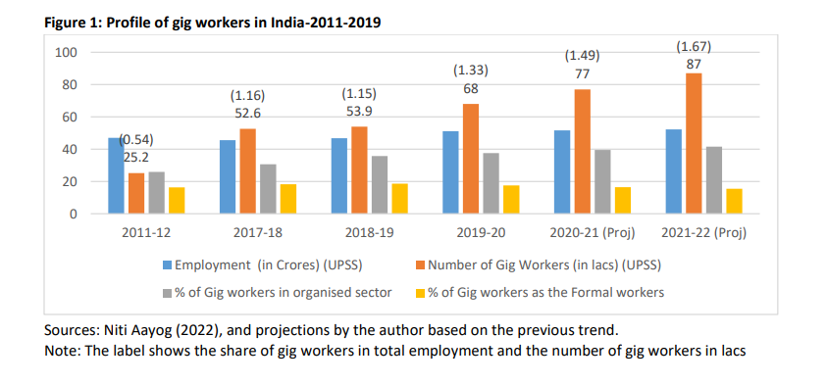

Figure 1 shows that the total number of gig workers were only 25 lacs in 2011-12 when the gig economy had started taking the present shape and constituted just 0.54 percent of the total employment of 46.99 crores. Of these gig workers, only 26 percent were working in the organised sector6 and the share was only 16.3 percent of the formal workers.7 The picture has changed since then and in 2019-20, the number of gig workers by UPSS has increased to 68 lacs (6.8 million) with a share of 1.33 percent. Simultaneously, the share of gig workers in organised sector and as formal workers has also gone up, indicating that the speed of increase in the number of gig workers is faster in the organised sector as compared to the unorganised sector. It is however noticed that while the absolute number of gig workers has increased continuously in all the three years from 2017-18 to 2019-20, the share of gig workers as formal workers has declined between 2018-19 and 2019-2020. The projected numbers for 2020-21 and 2021-2 are also provided in Figure 1 and are useful in understanding the impact of COVID-19. The Aayog has also projected the number of gig workers to increase to 23.5 million by 2030.

The Niti Aayog report has also estimated and projected the distribution of gig workers by skill category,8 and it is summarized in Figure 2. The Figure shows that between 2011-12 and 2019-20, the share of low skill and high skill gig workers has increased and that of the medium skill has reduced (by 7 percentage points). It reflects the changing nature of work and the skill requirement. While the trend show that the concentration of middle skill workers may continue for few more years but gradually, because of the changing nature of work which is becoming more technology based, the demand and share of the high skill work may increase faster. The trend may also be accentuated because of the changing importance of industries and the occupations where the gig workers are employed.

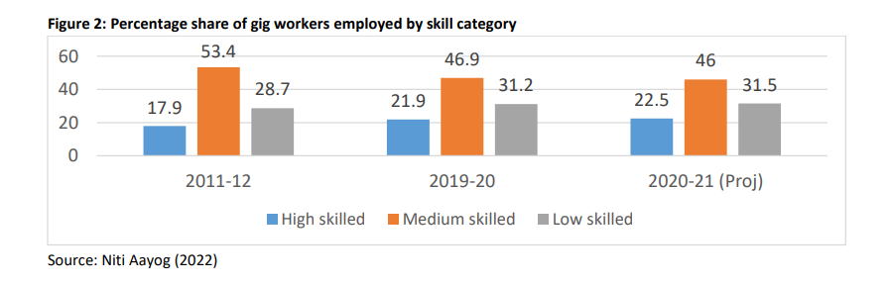

Distribution of gig workers by industry and occupation

The summary of the industries and the occupations where the gig workers are employed is presented in Figures 3, 4 and 5. It is evident from Figure 3 and 4 that the maximum number of gig workers- more than 26 lacs in 2019-20 with a 40 percent share are employed in retail trade, followed by 13 lacs in transportation and storage with a share of 19 percent, and in both manufacturing sector, and financial & insurance sectors with around 6 lacs workers and a share of 9 percent in each. Out of all the four sectors, the maximum increase in the number of gig workers over the year 2017-18 has been in retail trade, financial & insurance activities, and transport & storage. There is however, an expansion in almost all industrial sectors despite the changing sectoral concentration. From the expansion in different industries and the projections made, it is expected that the gig workers are here to stay and would expand further.

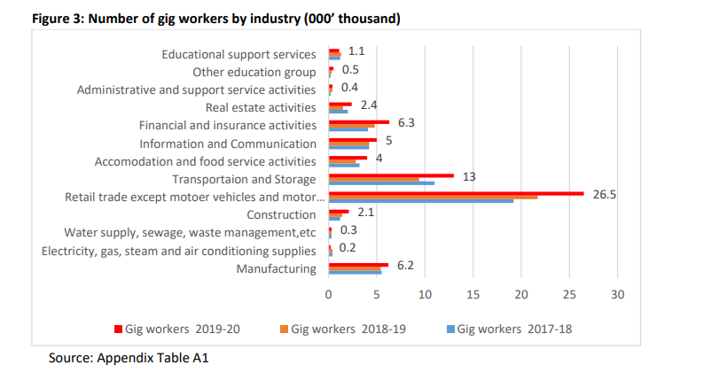

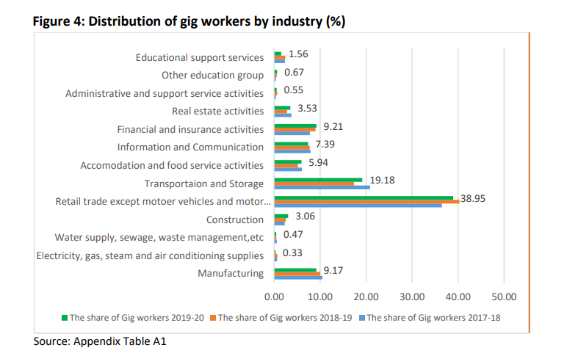

In Figure 5, the occupational distribution of the gig workers highlights the occupations in which the gig workers are broadly engaged. It indicates that some occupations are growing and becoming more important from the perspective of employment of gig workers and one can map the skill requirements of these occupations and accordingly upskill or reskill the existing labour. In terms of occupation, as defined by the National classification of occupation (NOC-2004), out of the total 68 lac Gig workers in 2019-20 about 23 lacs gig workers (one-third of the total) are employed as sales and marketing personnel, 13 lacs as motor vehicle drivers (about one-fifth), 6 lacs as secretary and clerks, and sales & finance associates are 5 lacs. These four categories together account for around 80 percent of the total gig workers and there has been only a small change in the shares. Out of a total increase of 15 lacs gig workers between 2017 and 2019, the maximum increase of 3.9 lacs has been for shop salespersons etc., followed by an increase of 2.8 lacs for Secretaries & clerks, and 2.1 lacs for motor vehicle drivers.

From the discussion on the gig workers it is clear that the estimates are a first major attempt by Niti Aayog, India to find the exact number of gig workers in India across industries and occupations. The estimates in the report are therefore based on certain notions about who are the gig workers and the likely industries and occupations where the gig workers may be working. The estimates may therefore suffer from inaccuracies and may have rendered it difficult to have the exact estimates because of use of certain restrictive assumptions related to the growth in population, employment, etc. at the economy level and the industry level. However, the report does provide ample idea of the magnitude and distribution of the gig workers in India, starting from 2011-12, 2017-18 up to 2019-20 and also makes some projections for 2020-21, 2021-22, and 2030-31.

The limitation of the current discussion is that in the absence of any other official source of information on gig workers, it is solely based the report by Niti Aayog, but it is hoped that with the availability of more data revisions could be made.

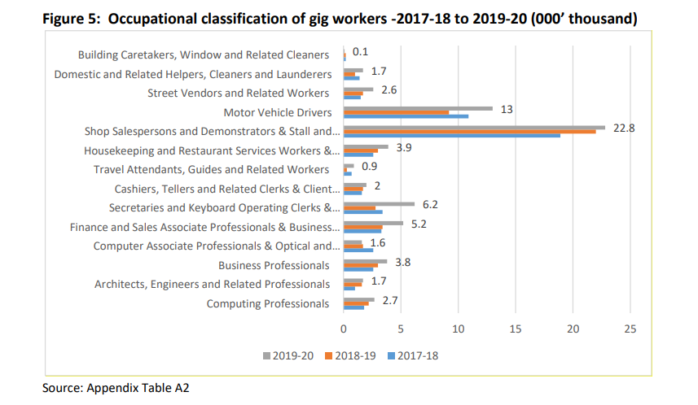

From the previous discussion of the self-employed, casual, and gig workers it is evident that while the share of self-employed and gig workers has increased in the recent period since 2017-18, the share of casual workers has marginally declined. It is also observed that the social security which is expected to be available to the regular wage/salaried employees, is also not available to more than 50 percent in 2021-22 and the overall status of labour in 2021-22 is precarious.

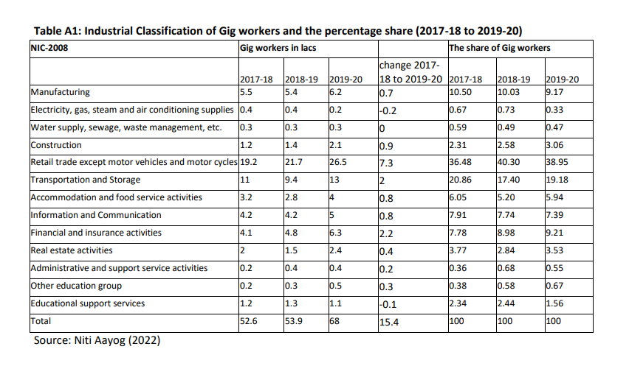

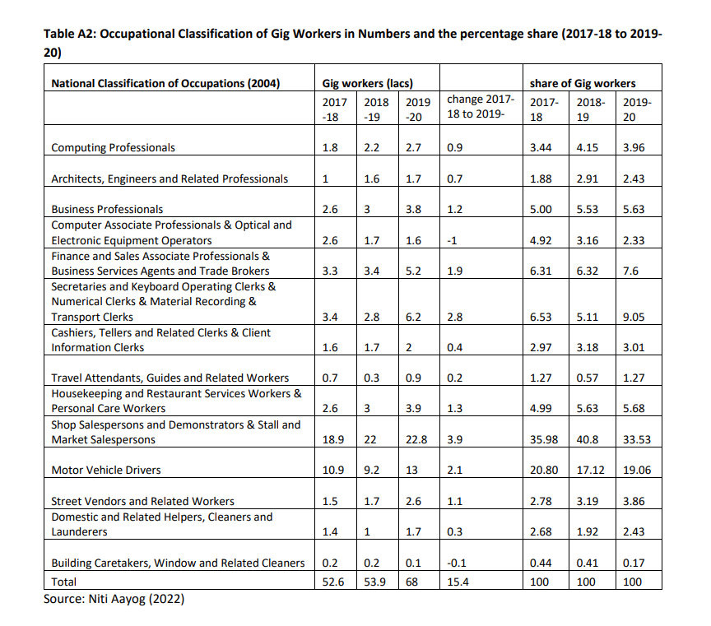

An article on FinancialExpress.com dated February 6, 2023

Indian gig workforce to witness 200% jump by 2030: Niti Aayog

The Indian gig workforce is expected to expand to 23.5 million workers by the year 2029-30, which is nearly a 200% jump from the current 7.7 million, a Niti Aayog report, ‘India’s Booming Gig and Platform Economy’, has revealed.

Overall, the demand for gig workers has increased by 10X whereas the participation of gig workers has increased by 3X in the year 2022 in comparison to the year 2021, the Taskmo report 2022 showed. “The participation of youth in the gig [economy](https://www.financialexpress.com/policy/economy/) has increased 8-fold between 2019 and 2022,” the report said.

Women’s participation has increased from 18% to 36% showing a remarkable growth of 2X last year whereas Youth participation in the Gig economy has seen an 8-fold increase between 2019-2022, the report further showed.

As per an Aon survey—’Decoding the Gig Economy’, 49% of the 145 companies have already employed gig workers and 65% plan to increase this number over the next two to five years. Hence, there is a vast potential for job seekers in blue, white, and grey collar [jobs](https://www.financialexpress.com/jobs-career/), it said.

The gig economy is predicted to be a significant building block in achieving [India](https://www.financialexpress.com/india-news/)’s aim to become a $5 trillion economy by 2025, the reports indicated. This would help in bridging the income and unemployment gap.

The Indian gig economy has the potential to serve up to 90 million jobs in the non-farm sectors of India (which is  
around 30%) with the potential to add up to 1.25% to India’s GDP through efficiency and productivity gains alone, a study conducted by Boston Consultancy Group (BCG) said.

**Gig economy’s impact on traditional Employment**

In recent years, the gig economy has surged, leading to profound and quantifiable impacts on traditional employment. This chapter delves into the data-driven facets of this transformation, shedding light on how gig work is reshaping the workforce and the broader economy.

**1. Explosive Growth of Gig Workers**

The growth of gig work has been nothing short of explosive. According to the U.S. Bureau of Labor Statistics, in 2005, approximately 10.1% of the workforce participated in alternative work arrangements, which include gig work. By 2017, this figure had surged to 15.8%, representing nearly 24 million Americans. This meteoric rise underscores the increasing prevalence of gig work in the labor market.

**2. Erosion of Traditional Job Security**

One of the most profound impacts of the gig economy is the redefinition of job security. Traditional employment, once synonymous with long-term stability, has become less secure for many. McKinsey Global Institute's research shows that over 20% of gig workers surveyed now rely on gig work as their primary source of income. While gig work offers flexibility, it often lacks the job security and benefits traditionally associated with employment.

**3. Wage Disparities and Income Volatility**

Wage disparities have emerged as a significant concern. Gig workers often earn on a per-task or per-project basis, which can result in income volatility. Studies conducted by the National Bureau of Economic Research reveal that, on average, gig workers earn less than their traditional employee counterparts when considering factors such as benefits and job security. This income gap raises questions about financial stability and income inequality.

**4. Benefits and the Safety Net Gap**

The gig economy's impact on benefits is glaring. Economic Policy Institute research indicates that only about 17% of gig workers have access to employer-sponsored health insurance, in stark contrast to the 70% of traditional employees who enjoy this benefit. Furthermore, the absence of retirement plans, paid leave, and other traditional benefits leaves many gig workers financially vulnerable and reliant on social safety nets, thus adding to the burden on public resources.

**5. The Imperative of Adaptation and Upskilling**

As traditional jobs face increased precariousness due to automation and outsourcing to gig workers, the imperative for reskilling and adaptation becomes paramount. According to a World Economic Forum report, by 2022, over half of all employees worldwide will require significant reskilling and upskilling. This reflects the urgency for workers to acquire new skills to remain competitive in an evolving job market.

**6. Emergence of Hybrid Employment Models**

In response to this evolving landscape, some companies are embracing hybrid employment models. A Mercer survey found that 58% of organizations are now utilizing gig workers alongside traditional employees. This fusion of employment types enables companies to tap into the flexibility offered by the gig economy while retaining a core of permanent staff.

**7. Policy Considerations**

The gig economy's impact has prompted discussions on labor policies. Governments and policymakers are grappling with the need to adapt labor laws and social safety nets to better accommodate the growing gig workforce. The goal is to strike a balance between worker protections and the flexibility that gig work offers.

The data paints a clear picture: the gig economy's impact on traditional employment is not merely a passing trend but a profound and ongoing transformation. While gig work offers newfound flexibility and autonomy, it often comes at the cost of job security, benefits, and financial stability. These statistics highlight the pressing need for individuals, businesses, and policymakers to adapt to these shifts and seek a balance that benefits both workers and the broader economy. The numbers unequivocally show that the gig economy is not just changing how we work; it's fundamentally redefining what work means in today's world. The challenges and opportunities presented by this shift are poised to shape the future of work for generations to come.